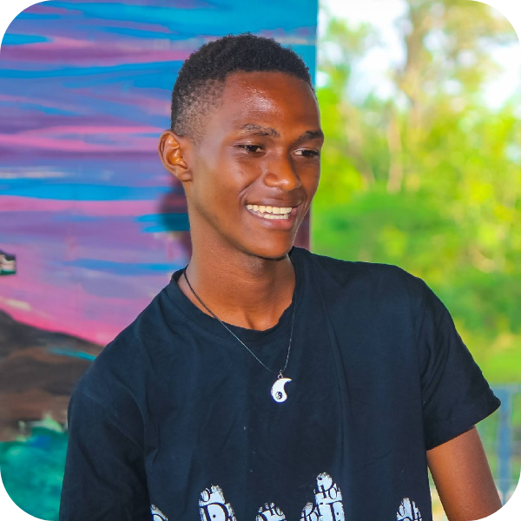

**Sidney Kyalo Mwanzia**

sidokyalo@gmail.com | +254114748466 | DoB: 20/05/2002

A student at Pioneer International University willing to learn new things and at the same time earn while

doing it.

A fast learner.

**PROFESSIONAL EXPERIENCE**

**10**

**/22 - 01/**

**23**

**BILILIGHT ENTERPRISES**

**Customer service and retail service assistant**

•

Work to ensure all individual and team targets are met.

•

Create a welcoming environment and provide excellent customer service.

•

Order and manage stock

•

Give customers correct advice and after understanding their needs, upsold services and turn bjectives

into sales opportunities.

**04**

**/21 - 01/**

**22**

**GOLDEN PALACE CASINO**

**Croupier(dealer)**

Trained and worked for Golden Palace Casino improving my observation skills and ability to work

unsupervised under high stress and pressure

•

Baccarat

•

7-card poker

•

Roulette

**05**

**/21 - present**

**Freelancing**

**Writer and Transcriptionist**

A freelance writer and transcriptionist available on multiple platforms eg kenyan writers and writershub.

Work with utmost great display of work and time management with a cheap price

**EDUCATION**

**09**

**/21 - present**

**PIONEER INTERNATIONAL UNIVERSITY**

**BACHELOR OF INFORMATION TECHNOLOGY**

•

Performed in cultural weeks poetry and modelling sessions

•

An outstanding student in practical IT skills

**01**

**/17 - 05/**

**21**

**ST. CHARLES LWANGA**

**Highschool - B. 64 POINTS**

•

Vice chairperson of Music club

•

Regular basketball player

•

Regular volleyball player

•

Regular table tennis player

•

Science club member



**01**

**/07 - 12/**

**16**

**GOOD SHEPHERD ACADEMY**

**KCPE 386marks**

•

Compound prefect

•

Headboy/ President of School

•

Head of Science Club

•

Head of Maths Club

**PROJECTS**

**Volunteer work**

•

Joined a volunteer group called Tumaini which deals with helping kids in need and addressing youth

problems among young adults -Kitui County

•

Participant in cleaning session with Church of God Ngara(2022)

**IT departmental course**

•

Database- intro to SQL

•

Android- chat bot creation and modification(Huawei)

**Science Project**

•

Automated Led car lights to prevent temporary blindness to drivers reducing accidents (2019)

**WEBSITE DESIGNS**

•

A JUNIOUR WEB DEVELOPER below is the link to github webpage and link to my website login pages

**KEY SKILLS**

•

A Junior website designer proficient in html, css and javascript. Also proficient in frameworks like

Bootstrap.

•

Croupier-Baccarat,7-card table and Roullete dealer with great skills on observation and practical work

•

Writer-ghostwriting,copywriting , article writing and seo writing qualified freelancer

•

**INTERESTS**

•

Music vice chair(2020)

•

Science regional project(2020)

•

Reading books(fictional, non-fictional)

•

Occasional volleyball player Kitui club

•

Table tennis (2018)

•

Active member of poetry club Pioneer University